Creating new floorplans

Open JDA Floorplanning

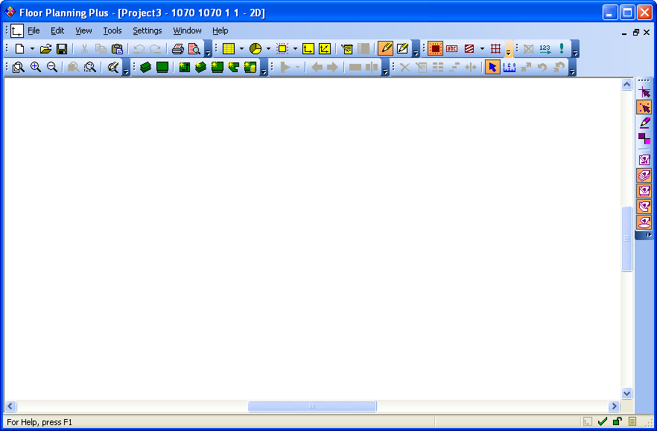 | Open JDA Floorplanning
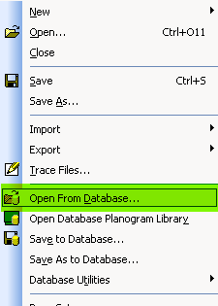 | FILE > Open From Database  We will open a Floorplan in the database
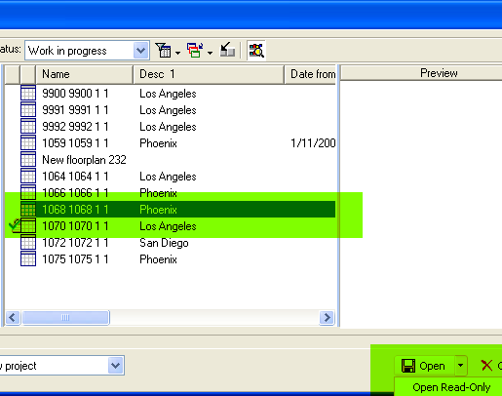 | Select the Floorplan you will work on  Click OPEN
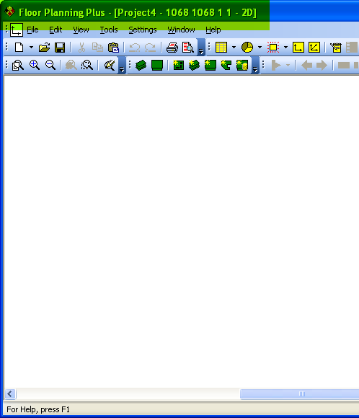 | Floorplan is loaded  As you can see from the highlighted info it provides you the floorplan info that you opened
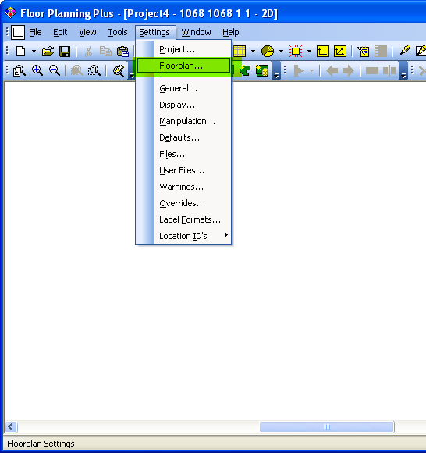 | The floorplan
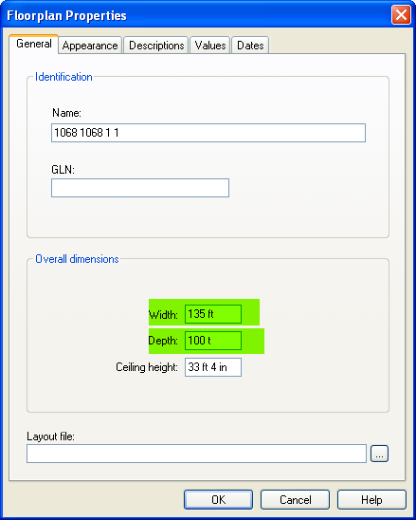 | The floorplan Properties window  Modify the Width to 135 ft  And  Depth to 100 ft  This is to create a GRID to work on the floorplan, this GRID will be able to identify what will be in the Floorplan

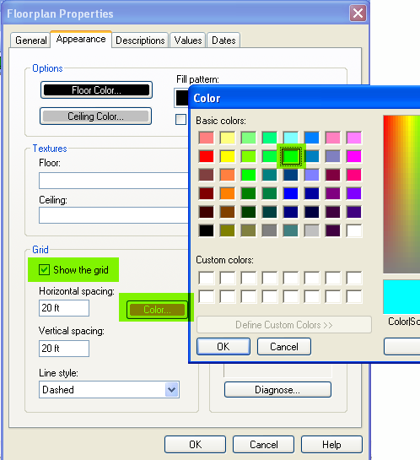 | Select the Appearance tab on the top  This will take you to another screen  Check the Grid  Check the Color  Select a color that will stand out so it will be easy to identify the grid

